Adding Minecraft Education to computer

- From an admin account (teacher accounts and administration accounts are all considered admin accounts) go to the following link here
- From the webpage click on the purple “GET STARTED” button located on the top banner

- On the next page click on the “DOWNLOAD NOW” button (circled in red)
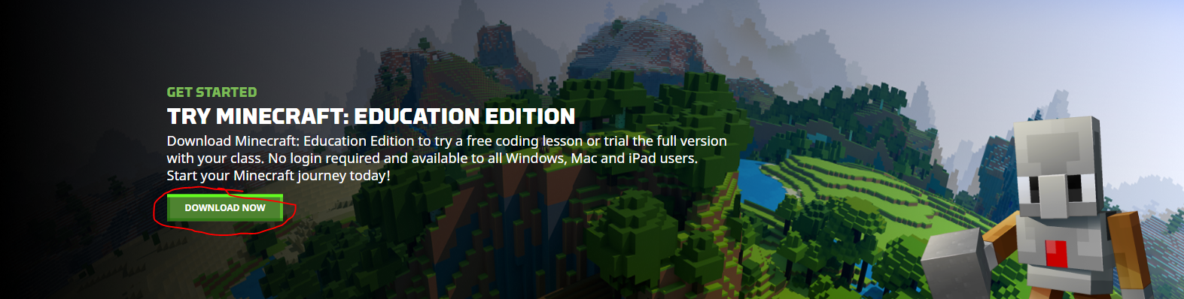
- For the download platforms if using a windows computer download the file for windows and vice versa for mac operating systems
  - Note: whether it is a laptop or desktop computer, the “desktop” file will work for both
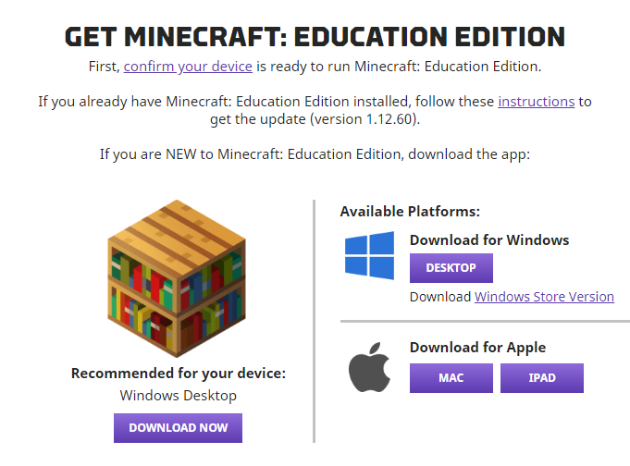
- Once the download begins you will see a dialogue box in the bottom left corner of the screen (if using google chrome)
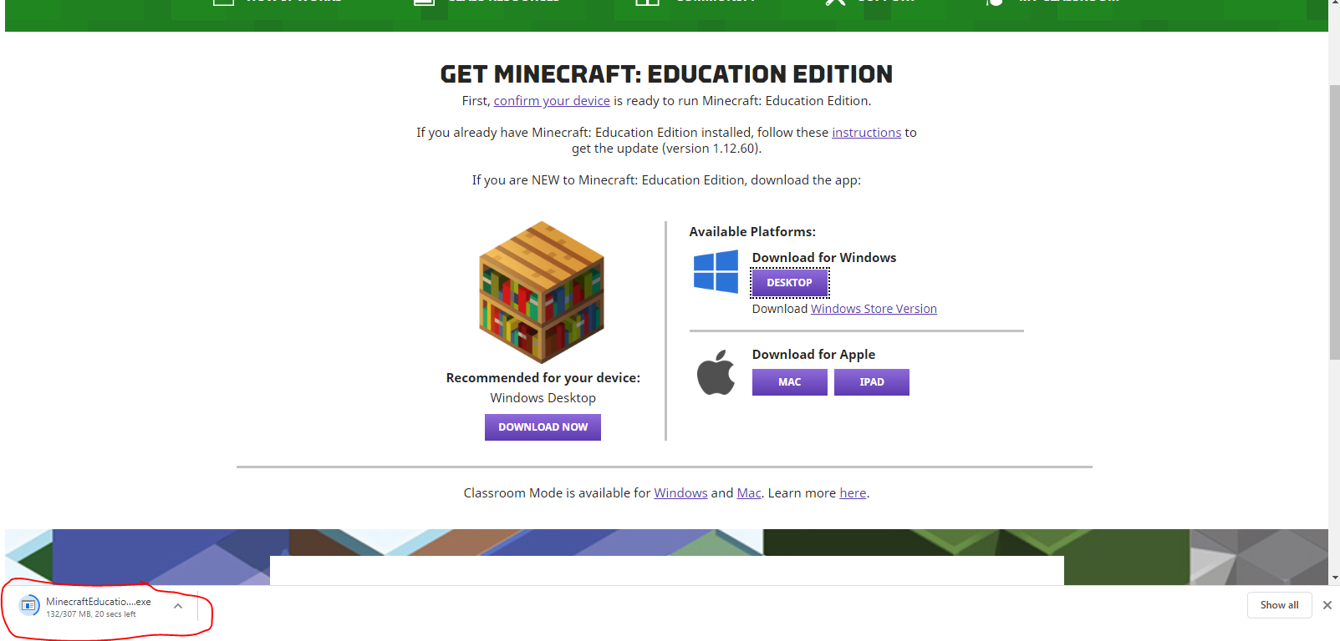
- Once download is complete left click on the file
- You will be presented with the install window (see image below)
- Select your setup language and then click “Next”
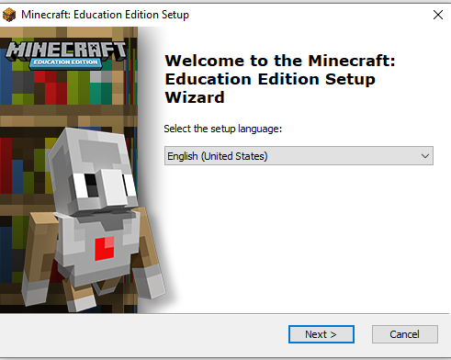
- You will then be brought up to the next window for the install file, left click “Next”
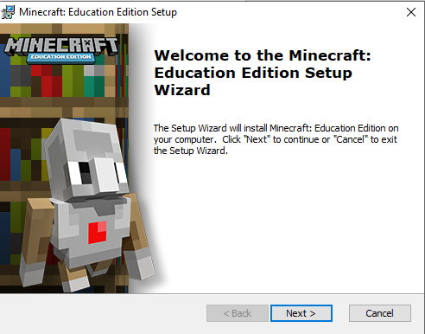
- You will then be brought to the EULA (End User License Agreement)
  - After reading the license agreement left click on “I accept” and then left click on “Next”
- 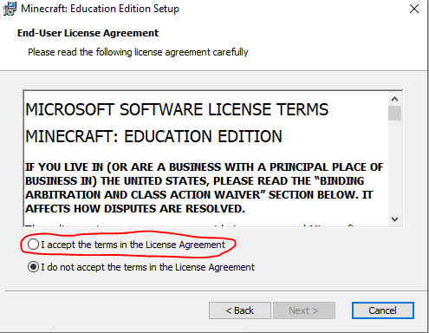
- At the next window left click on “Next”
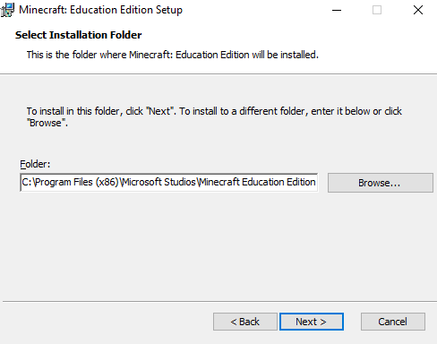
- If you would like a desktop icon shortcut
  - Ensure that box on the left of “Desktop” is checked (this is checked by default)
- If not
  - Left click on the box left of “Desktop”
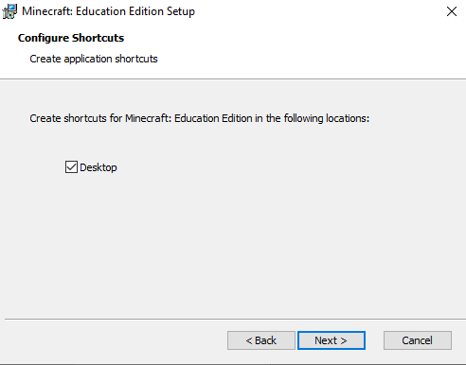
- On the next window left click on “Install”
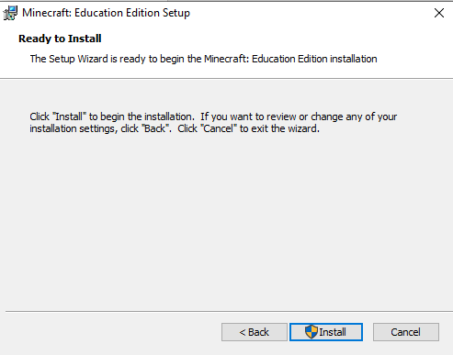

- The window down below should appear, this is indicating the file is installing on the computer
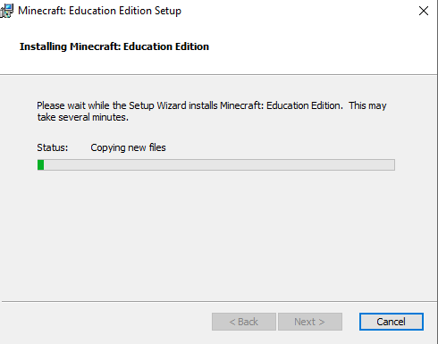
- Once installed the image below will appear
  - Uncheck the box by left clicking should you not want to start up minecraft, if you do want to use the application immediately – leave the box checked and left click on “Finish”
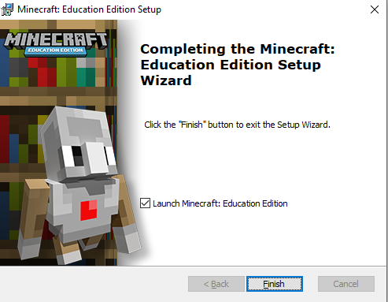

- Once you launch the application you will come across a sign in screen
  - At this screen have the students login with their fwps365 account
  - Example:
    - Username: StudentID@fwps365.org
    - Password: Password will be the password they use to login to an FWPS computer and their P12 account
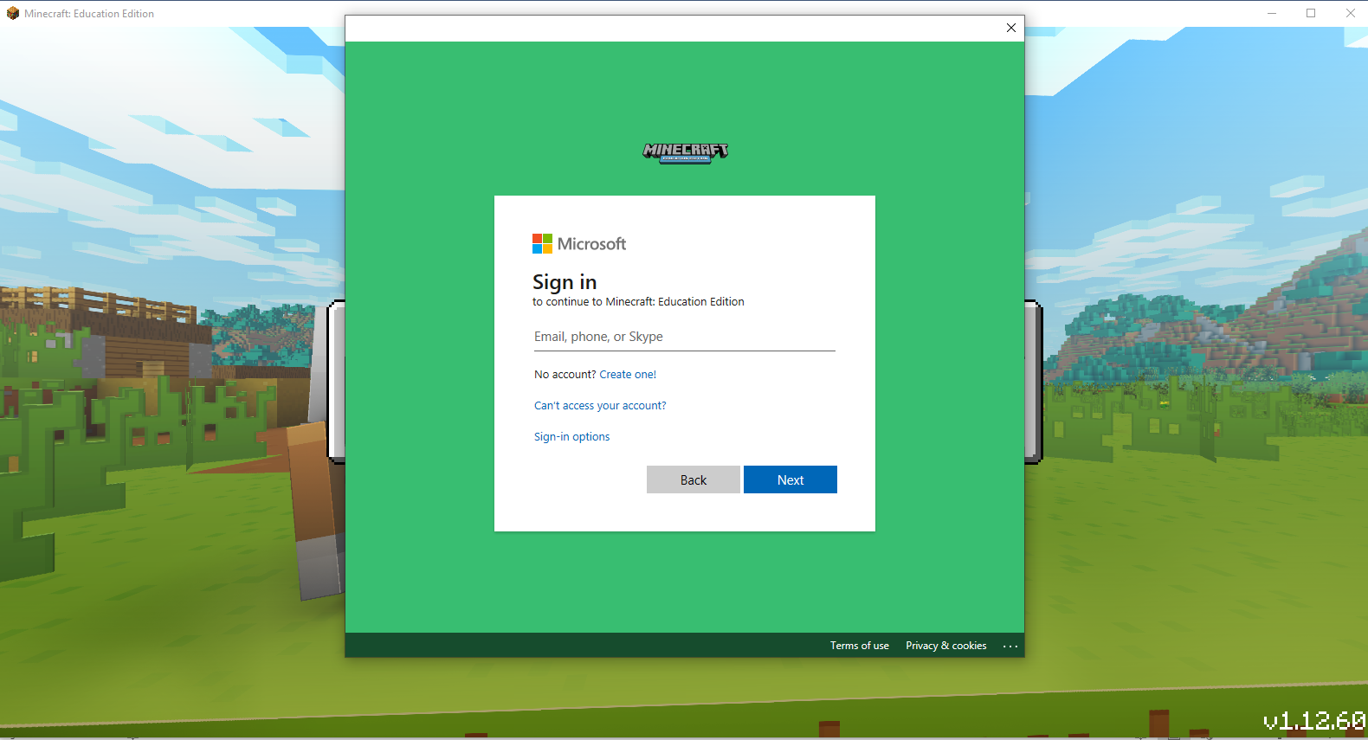

- Once you have logged in successfully, you will now be able to utilize Minecraft Education Edition within the classroom!
