Remote tech support

Quick Assist is a Windows 10 app. It allows someone you trust to take over your computer and help you solve a problem. To get started, your helper needs to launch the Quick Assist app, get a 6-digit code, and share that with you.

(Read below if you are an IT admin)
Give assistance
  - Select the Start button
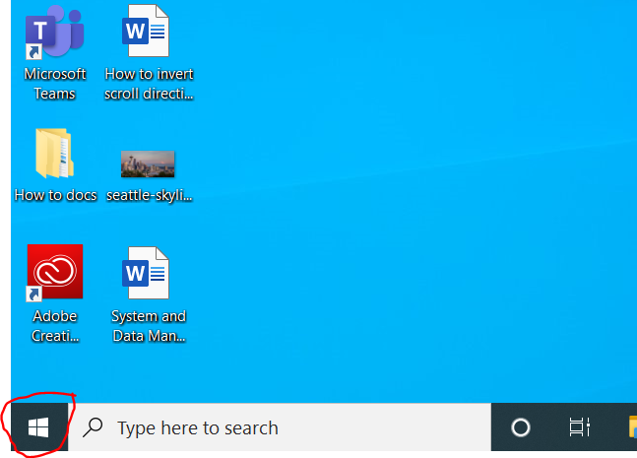
  - Type Quick Assist in the search box, then select it in the results).
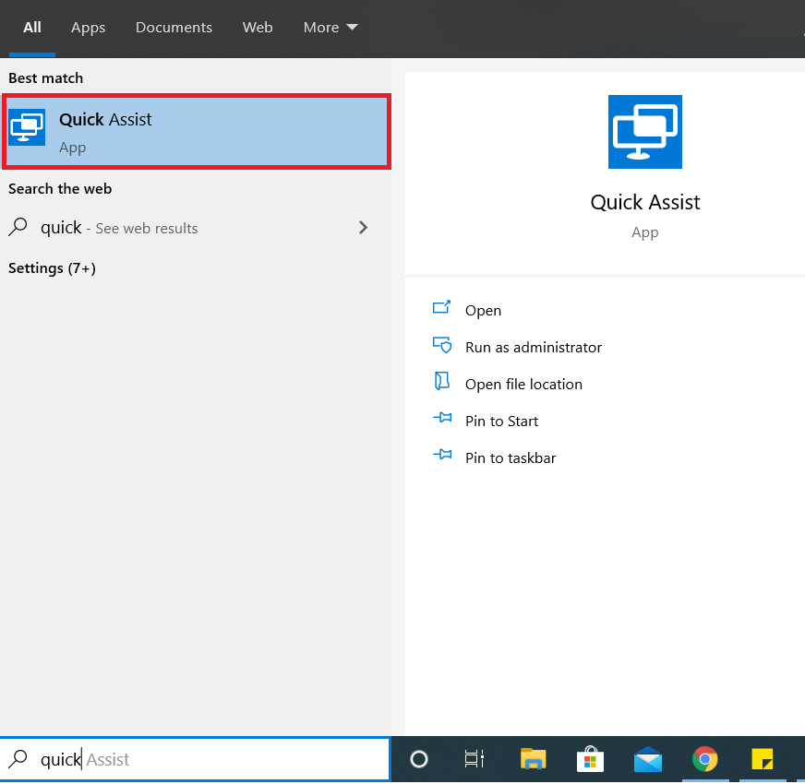
  - Select Assist another person
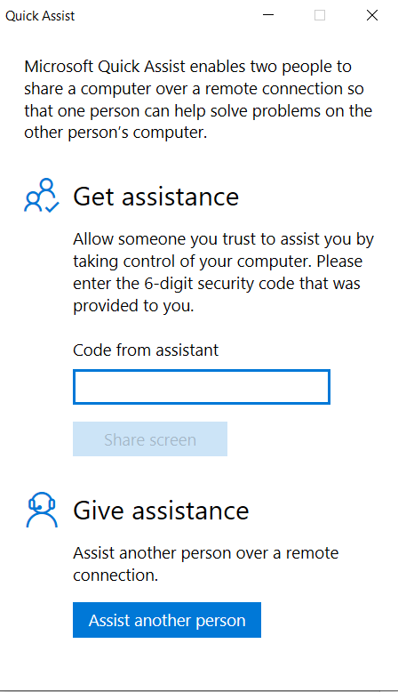

  - Then send the 6-digit code to the person you're helping
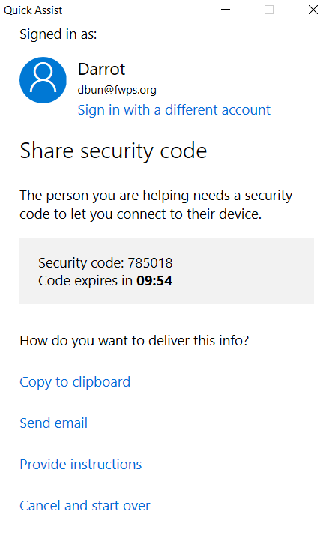
  - When they've entered it, select either Take full control or View screen. Once you’ve selected your desired preference, select continue 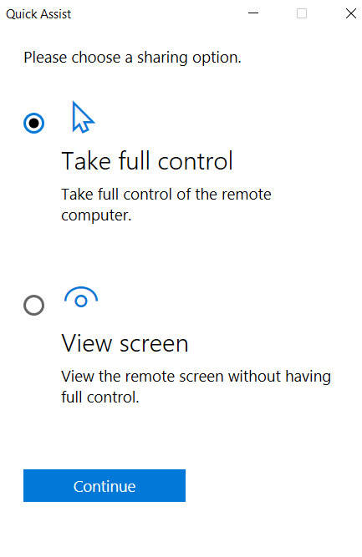

(Read below if you are a user receiving assistance from and IT admin)
Get assistance
- Select the Start button
- Type Quick Assist in the search box, then select it in the results).
- In the Code from assistant box, enter the 6-digit code you were given, and select Share sceen
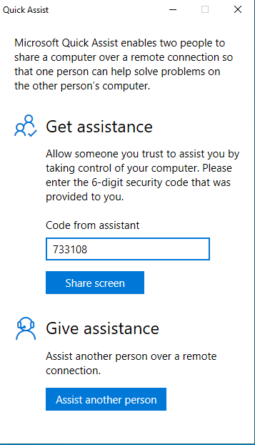
- Wait for your helper, then select Allow in the window that displays.
