Recalibrating touch function on smart boards
Sometimes you will notice when you go to touch anywhere on the smartboard your touch point on the screen is completely off from where your hand actually is. This article will go over on how to recalibrate your touch function. (See image below for which usb you will need in order to connect the smartboard to your desktop, laptop, and/or docking station.)
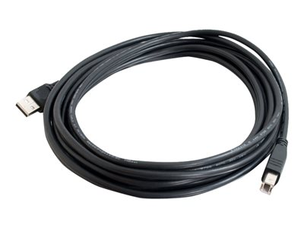
The USB cable you see above is most commonly known as a printer USB cable.
For this tutorial we will be using the smartboard 800 model (these are the models living in the classrooms at BCLS.) You should first notice if your usb wire is connected to the smartboard. 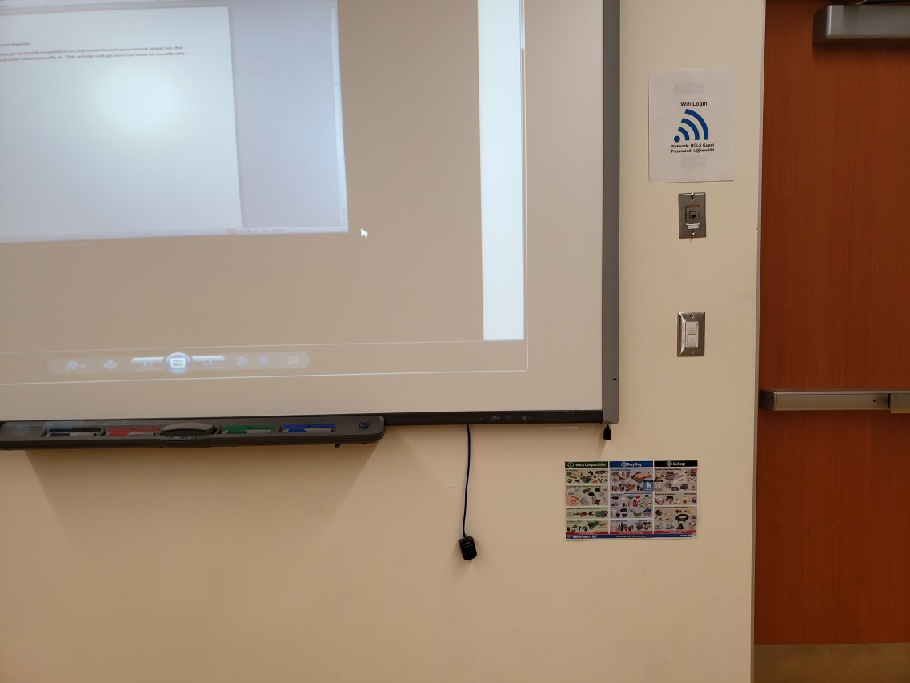
Where the red arrow is pointing above, is where we will need to connect the usb to.
Take the square end of the printer cable (on the right side of the image above) and plug that end into the connection where the arrow is pointing on the image with the smart board.
For the other end of the printer usb cable, you will want to put it into a usb slot located on the laptop, docking station, or desktop. See image below for what a usb slot looks like
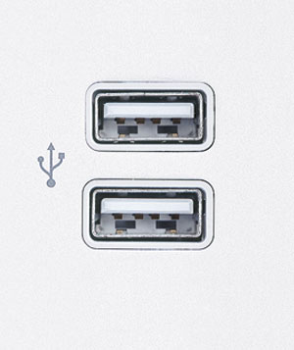
If the smartboard is not connected you will see the light indicator on the smartboard remains black (see image below)
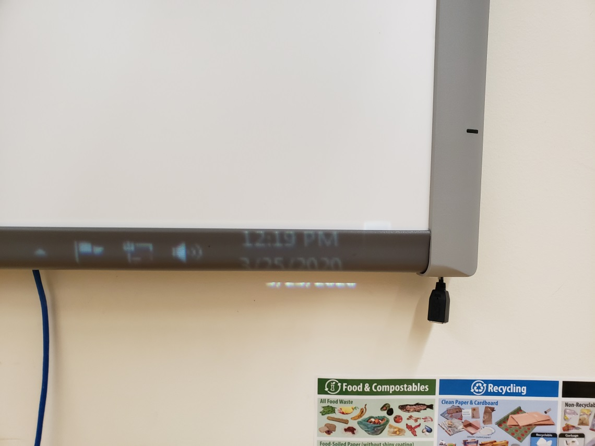
If the smartboard is connected you will see the light indicator light up green (See image below)
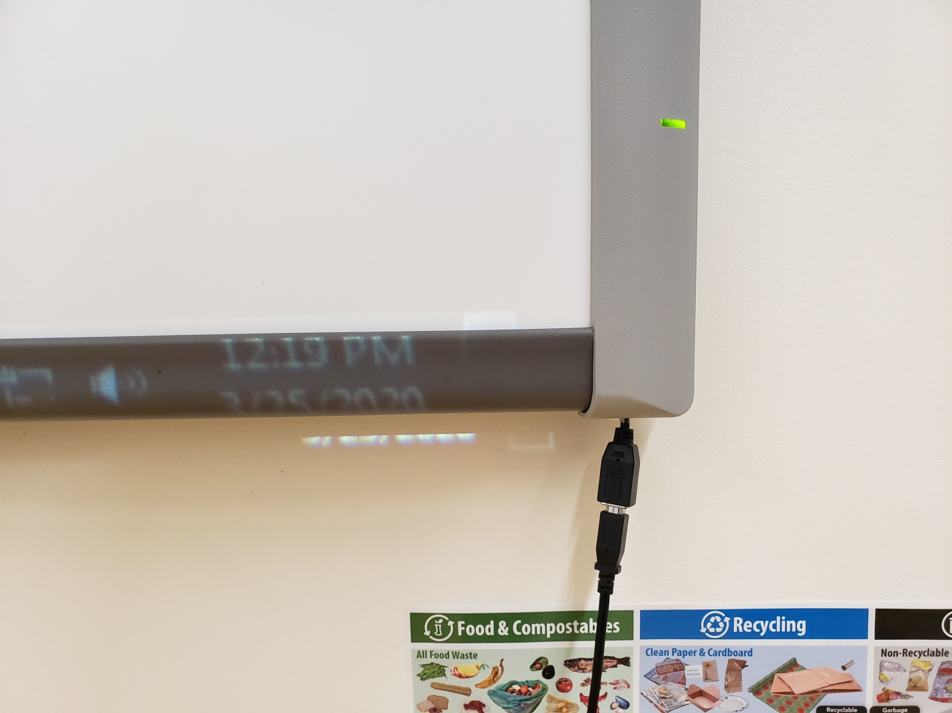

If your touch function is still not working, we will then recalibrate it using the SMART system menu.
In order to access the SMART system menu you will first have to download Smart Notebook. You can find the download for Smart Notebook here. Please consult with your IT admin if you have the correct licensing for Smart Notebook prior to downloading. You will be able to access the smart system menu without a subscription if needed, however Smart Notebook does offer a lot of features to further enhance the classroom experience.
After downloading smart notebook left click on the start button located on the bottom left of the screen. (Squared in red, see image below)

Begin to type in Smart Settings then left click on Smart Settings
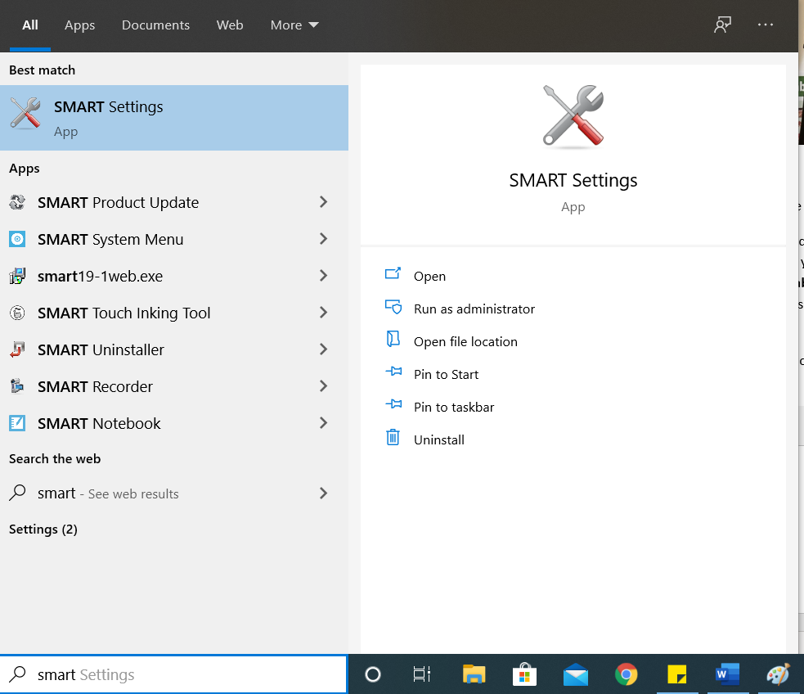

Once the smart settings window has launched left click on Orient/Align the SMART product
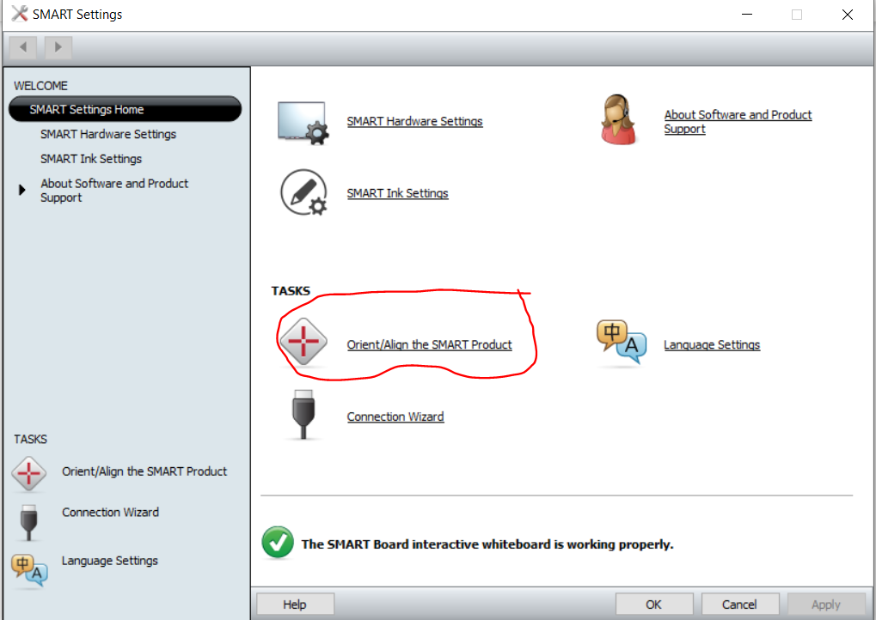
You will then be presented with the screen below
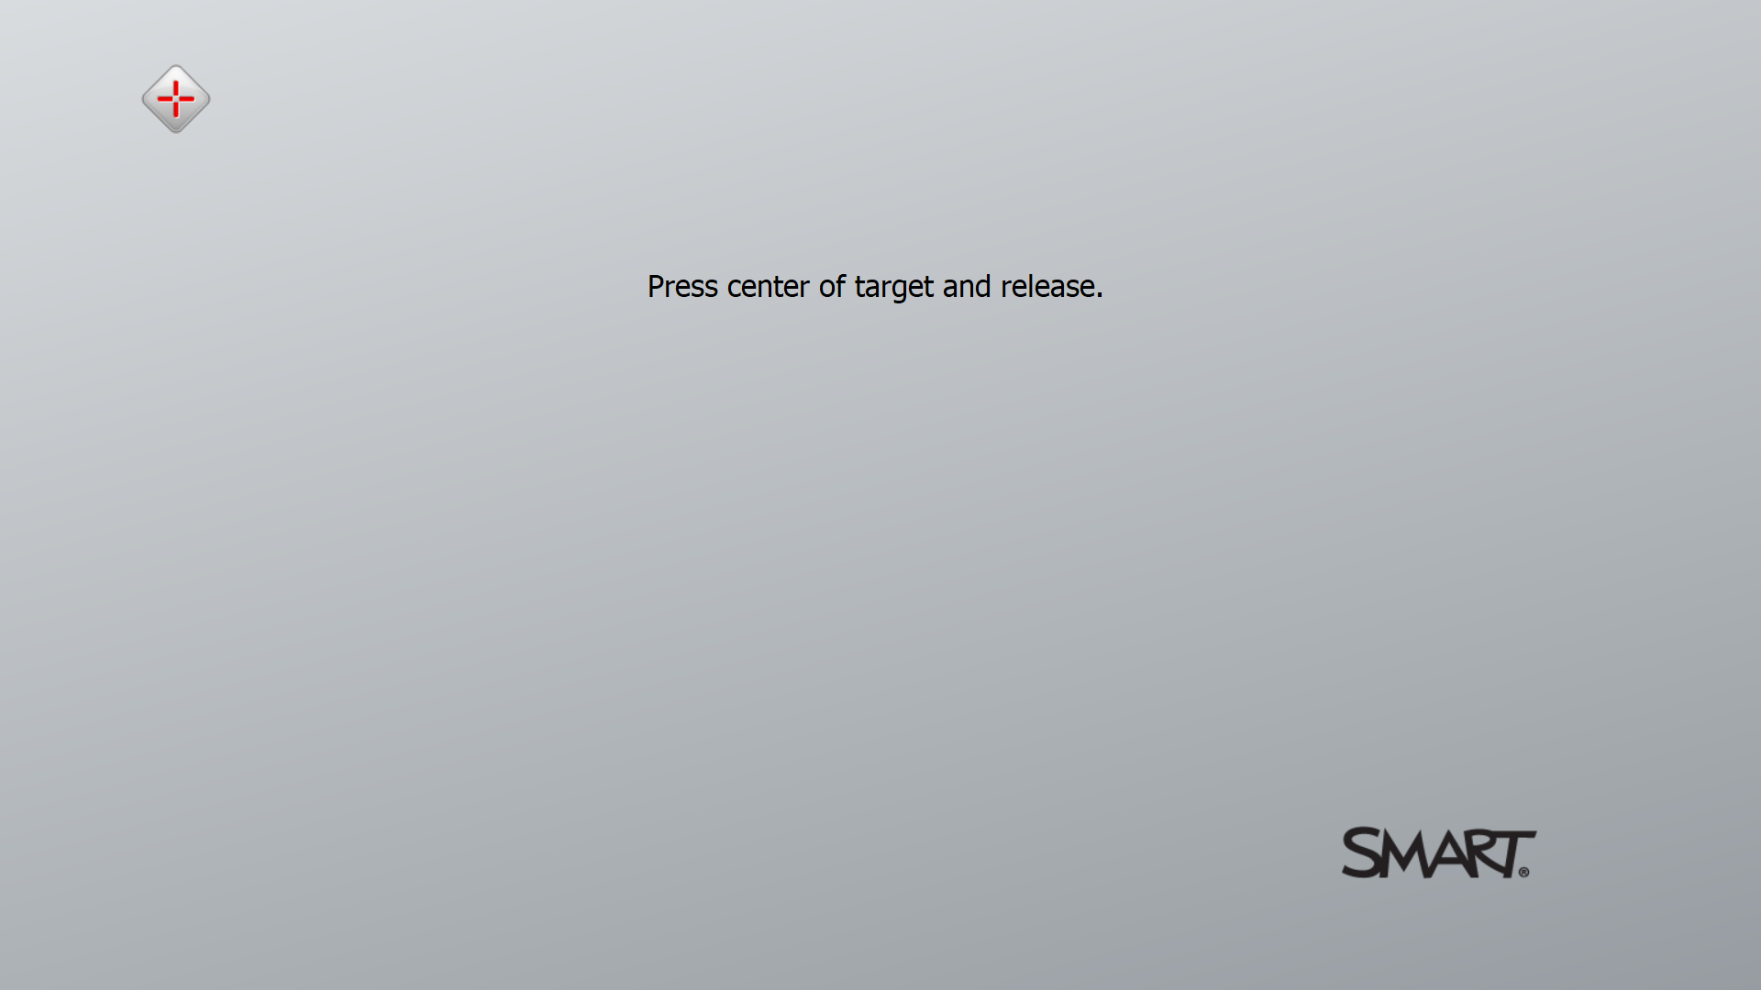
NOTE: Ensure the screen above is presented on the SMART board. What I mean is if you see the screen above on your computer monitor press the spacebar key on your keyboard to change the orient screen to the smartboard.

