Troubleshooting WIFI at TAF@SGH
There are many, many reasons why the wifi would not be working. This tutorial will go over a few methods on how to troubleshoot. This article will also be a live ongoing document so we are able to cover as many methods as we can.
Method 1
Using the command prompt “gpupdate /force”
- Select the start button on the bottom left of the screen
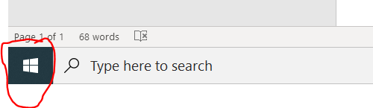
- Begin to type cmd
- Left click on command prompt
- A black window will then appear (see image below)
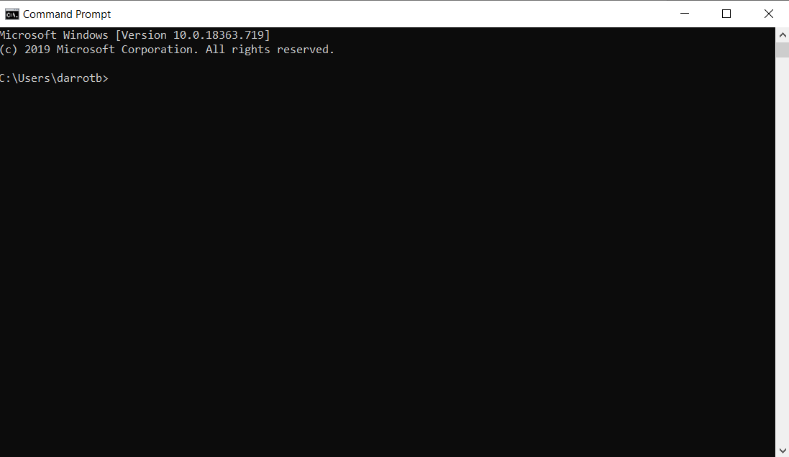
- Begin to type gpupdate /force and press enter
- The text in the command prompt window will then say the text below in this order
  - Updating computer policy
  - Computer policy updated
- Should you run into the text below in the command prompt, then contact your IT admin via zendesk
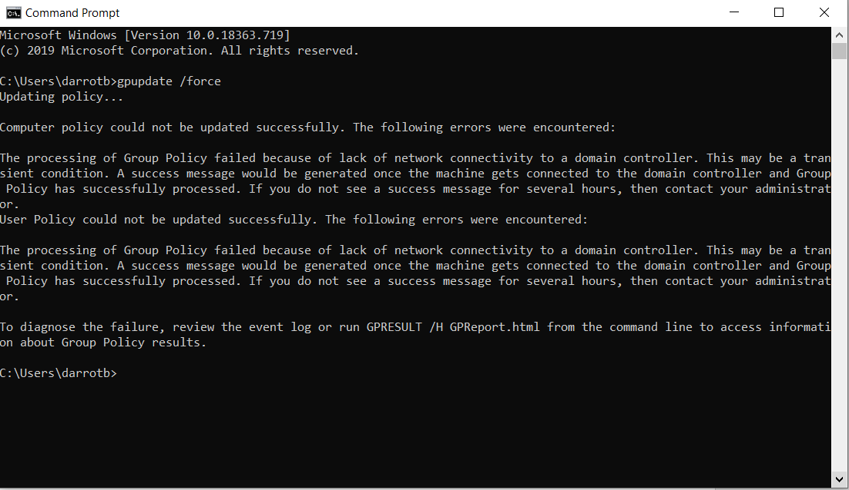

Method 2
Ensure wifi is enabled
- On the bottom right corner of the screen where the clock is located you will see some icons
- You will know wifi is not enabled when you see the image below
  - 
- To enable wifi left click on the icon
- Left click on wifi
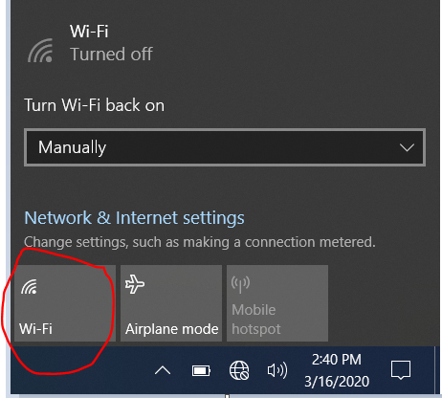
- A list of available wifi connections will then appear (see image below)
  - You will then need to input the correct login information to successfully connect to the corresponding wifi connection
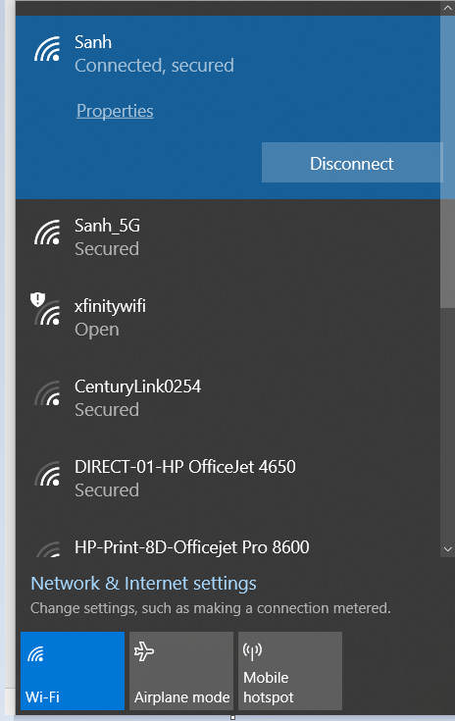
NOTE: If wifi still isn’t working, contact your IT admin via zendesk

Method 3

