To add a new keyboard layout on Windows 10, use these steps:
- Open Settings.
- Click on Time & Language.
- Click on Language.
- Select your default language from the list.
- Click the Options button.
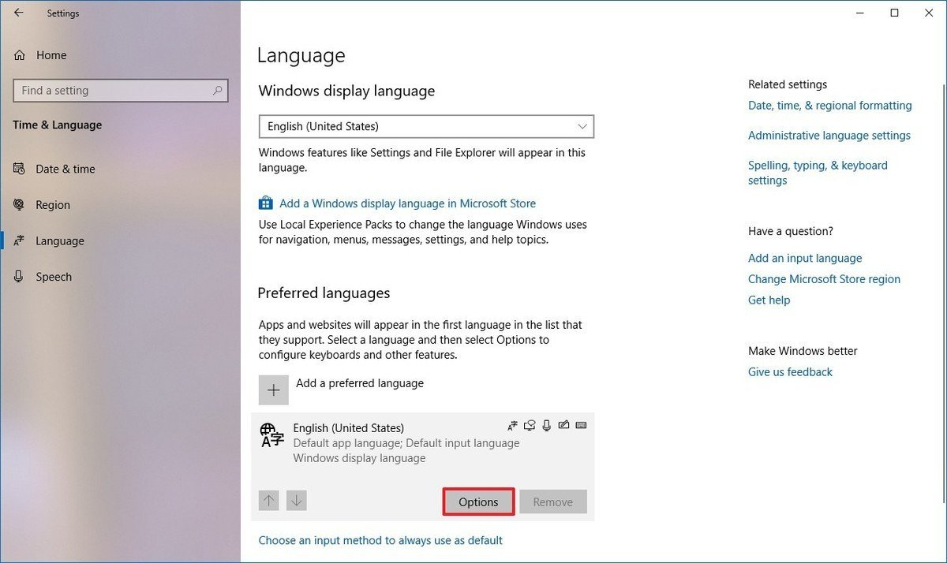
- Under the "Keyboards" section, click the Add a keyboard button.
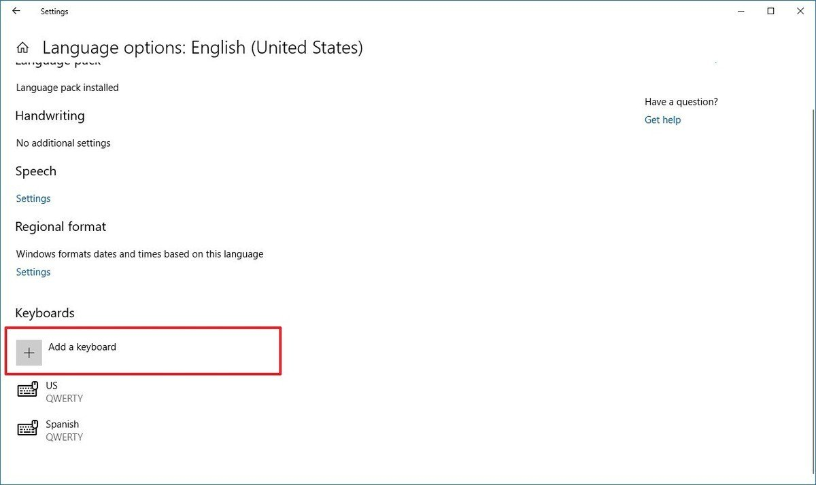
- Select the new keyboard layout that you want to add.
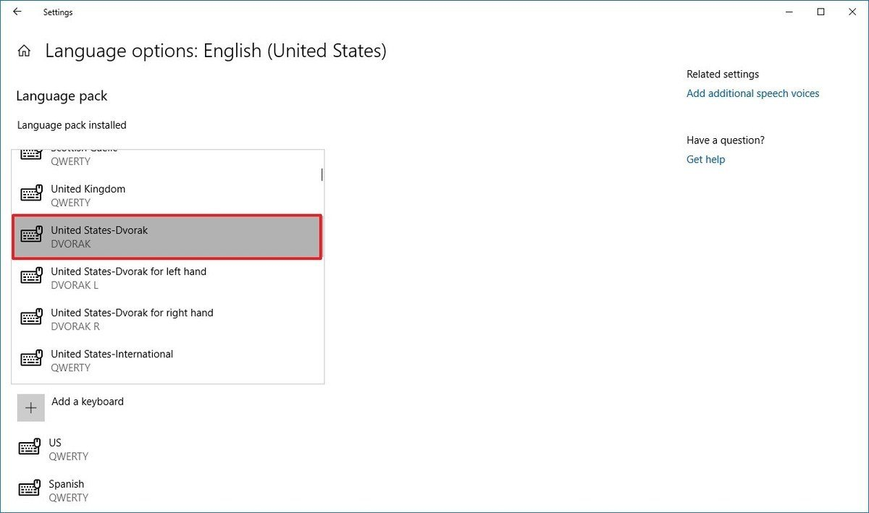
Once you complete the steps, the new layout will be installed on your device.

