How to add Microsoft Office Suite with an Office 365 account – TAF EMPLOYEE GUIDE
All TAF employees have an office 365 account. Their 365 account is their techaccess.org email.
Example: darrotb@techaccess.orgg
Your password for your office 365 account is unattached from your techaccess gmail password. If you would like to reset your office 365 password please see your IT admin to reset it.
With a 365 account you will also be able to download Microsoft office onto any computer at home up to 10 times. You will not be able to install past 10 computers
- Open a web browser of your preference
  - For this tutorial we will be using the google chrome web browser
- Go to www.office.com or click here
- You will then be presented with the login page (see image below)
  - You can enter your email address
  - TAF Employee email address: employee@techaccess.org
  - Password: Office 365 password
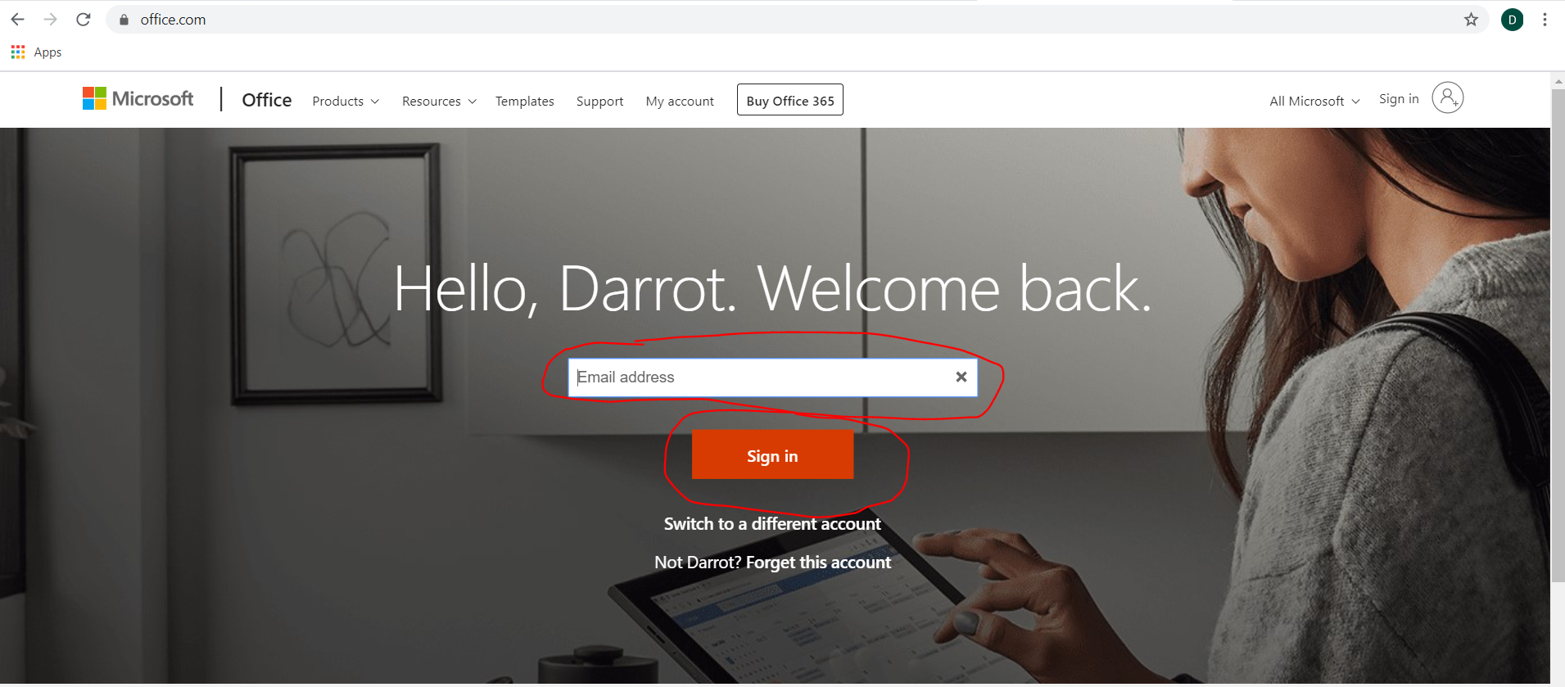

- At the next window if you left clicked on the “Sign in” button you will then enter your email address (See image below)
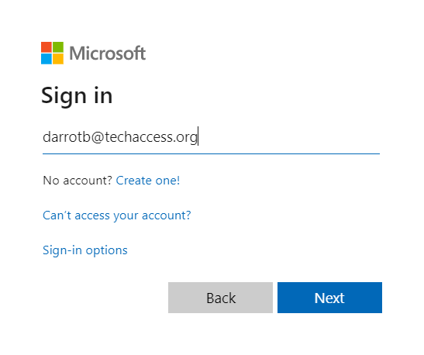
If you are signing in for the first time you may see this image before inputting your password, be sure to select the option in grey
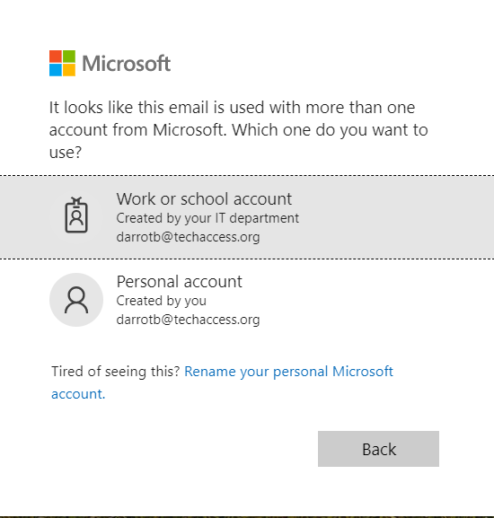

- On the next window you will then enter your office 365 password
  - If you do not know your office 365 password, please contact your IT admin to have it reset

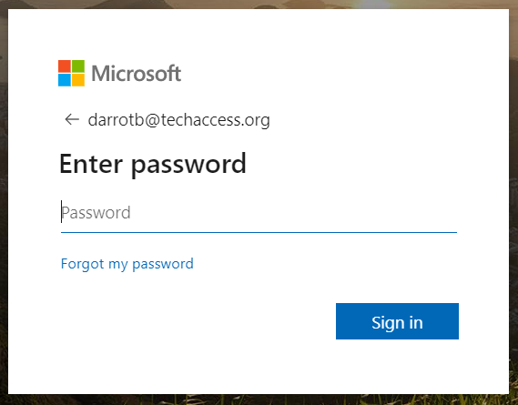

- On the next window you will then be presented with the image below
  - To install Microsoft Office click on the button “Install Office” which is circled in red in the image below
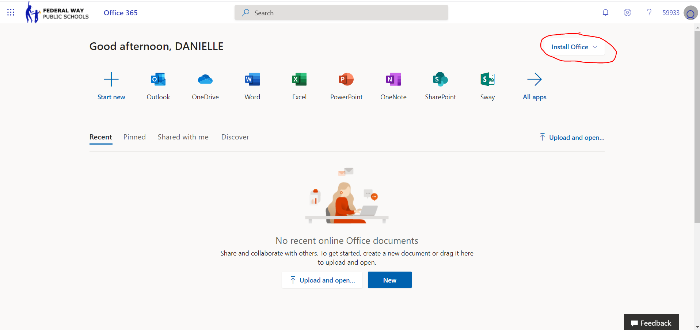
- Once you click on “Install Office” button it will then expand to two options
  - By default the language is set to English. If you would like to install in another language of your choosing, select the second option.
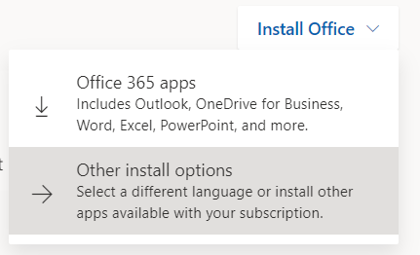
- Once you left click on “Office 365 apps” you will then be presented with the image below
  - You will know the download has begun if you see the download bar appear in google chrome (see box that is circled in red)
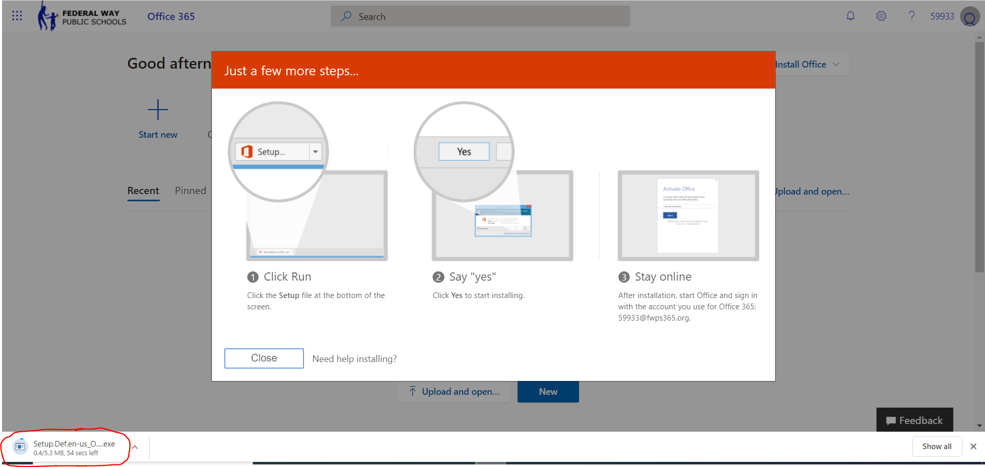

- Once you have left clicked on the download, the install will begin automatically
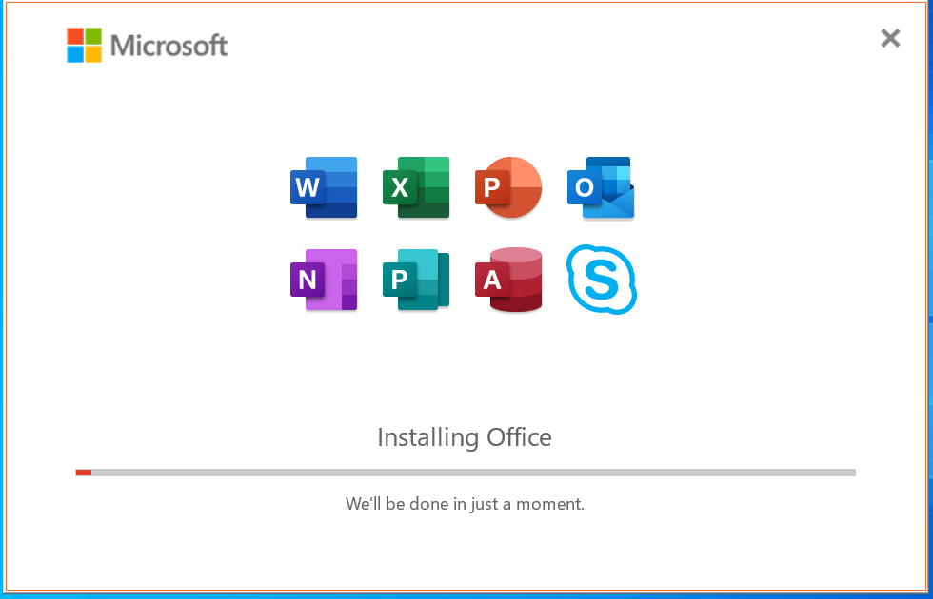

- Once the install is successful you will then be presented with the image below
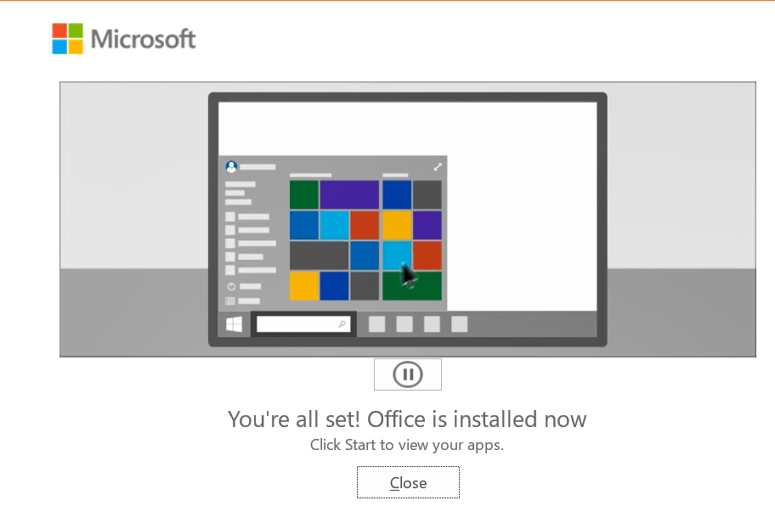
- Once you’ve installed Microsoft office onto your computer successfully you should then test it by opening a Microsoft office app such as “Word” or “Powerpoint”

