Basic Smartboard troubleshooting
- If there are any other scenarios that you would like to see addressed in this troubleshooting guide please contact Darrot bun at darrotb@techaccess.org
How to restart the smartboard
- To restart the smartboard you’ll simply have to press and hold (hold down the button for 3 seconds) the crescent moon button located on the control panel of the smart board.
Smartboard not turning on:
Check if it's plugged in:
- Is the power cable plugged into the wall?
- If using a power strip or extension cord:
  - Is it plugged in securely?
  - Is it turned on?
- Is the power cable firmly connected to the back of the Smartboard?
- Ensure the smartboard power switch is switched to “on”
  - The power switch is located on the bottom of a back panel on the smartboard
  - 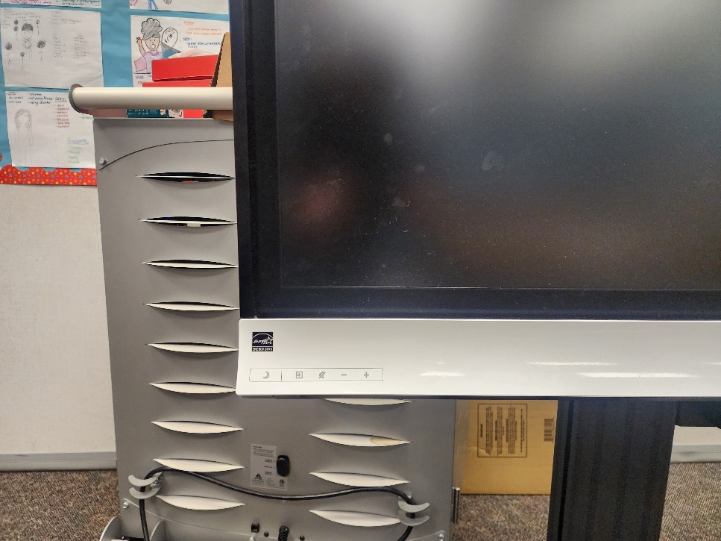
- 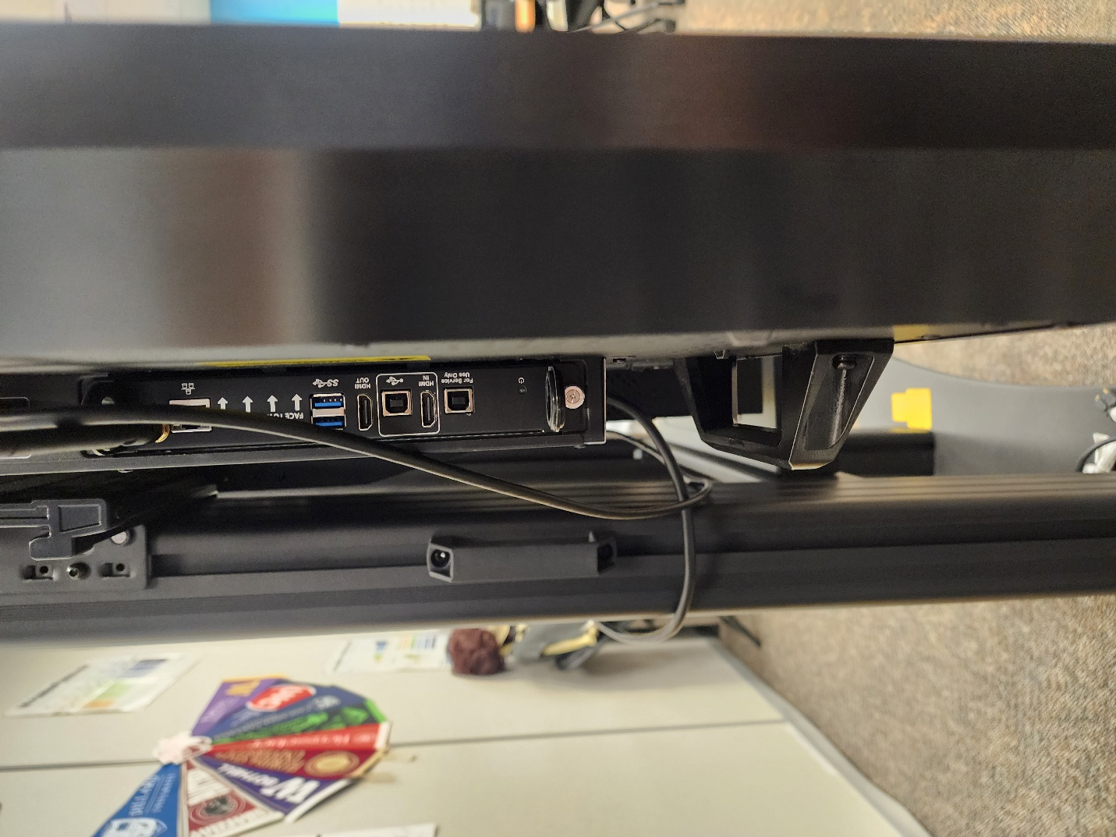
- The power switch is located along the bottom of this panel (referring to the picture above)
- 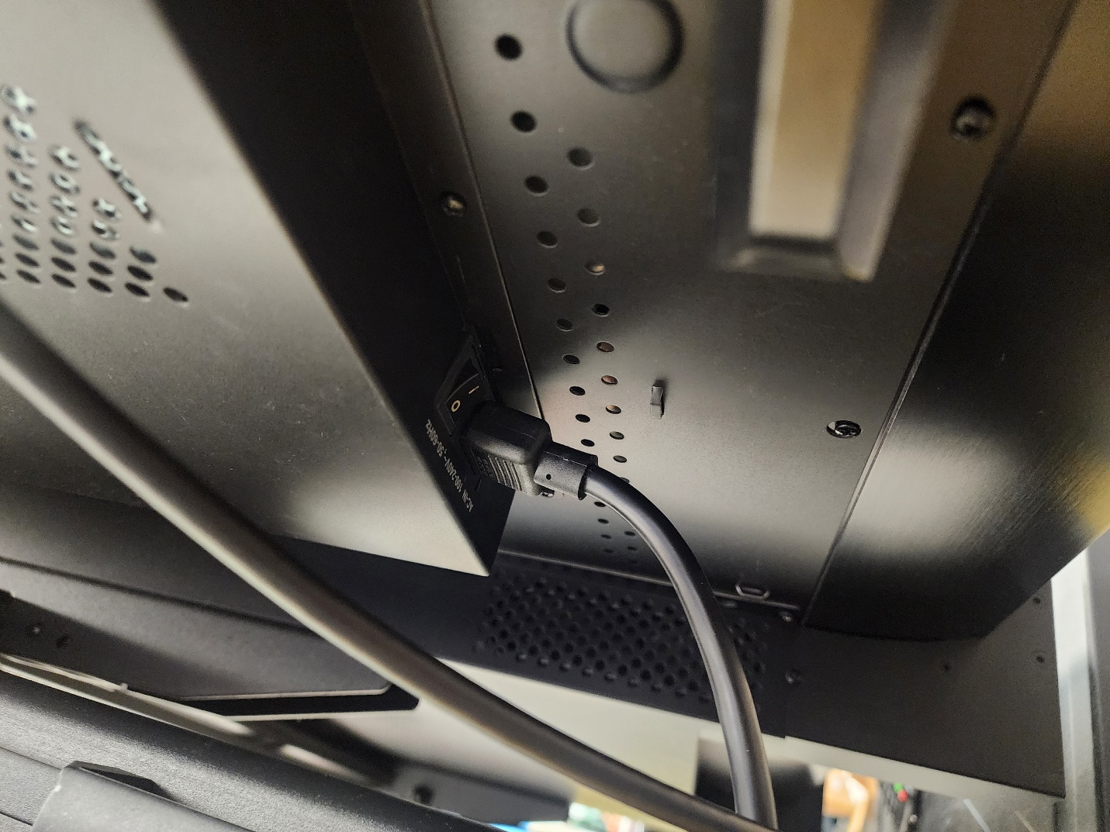
- It is located just right before the power cable that’s plugged into the back of the smartboard
- Ensure that the switch is flipped to on (the switch the red arrow is pointing to)

Smartboard wifi isn’t working

- Ensure the date and time are correct
  - Why?
    - A Smartboard needs the correct date and time to connect to WiFi properly. If the date and time are wrong, the board might not recognize the network or may block the connection for security reasons. Fixing the date and time helps it connect smoothly without issues.
  - How to adjust date and time settings
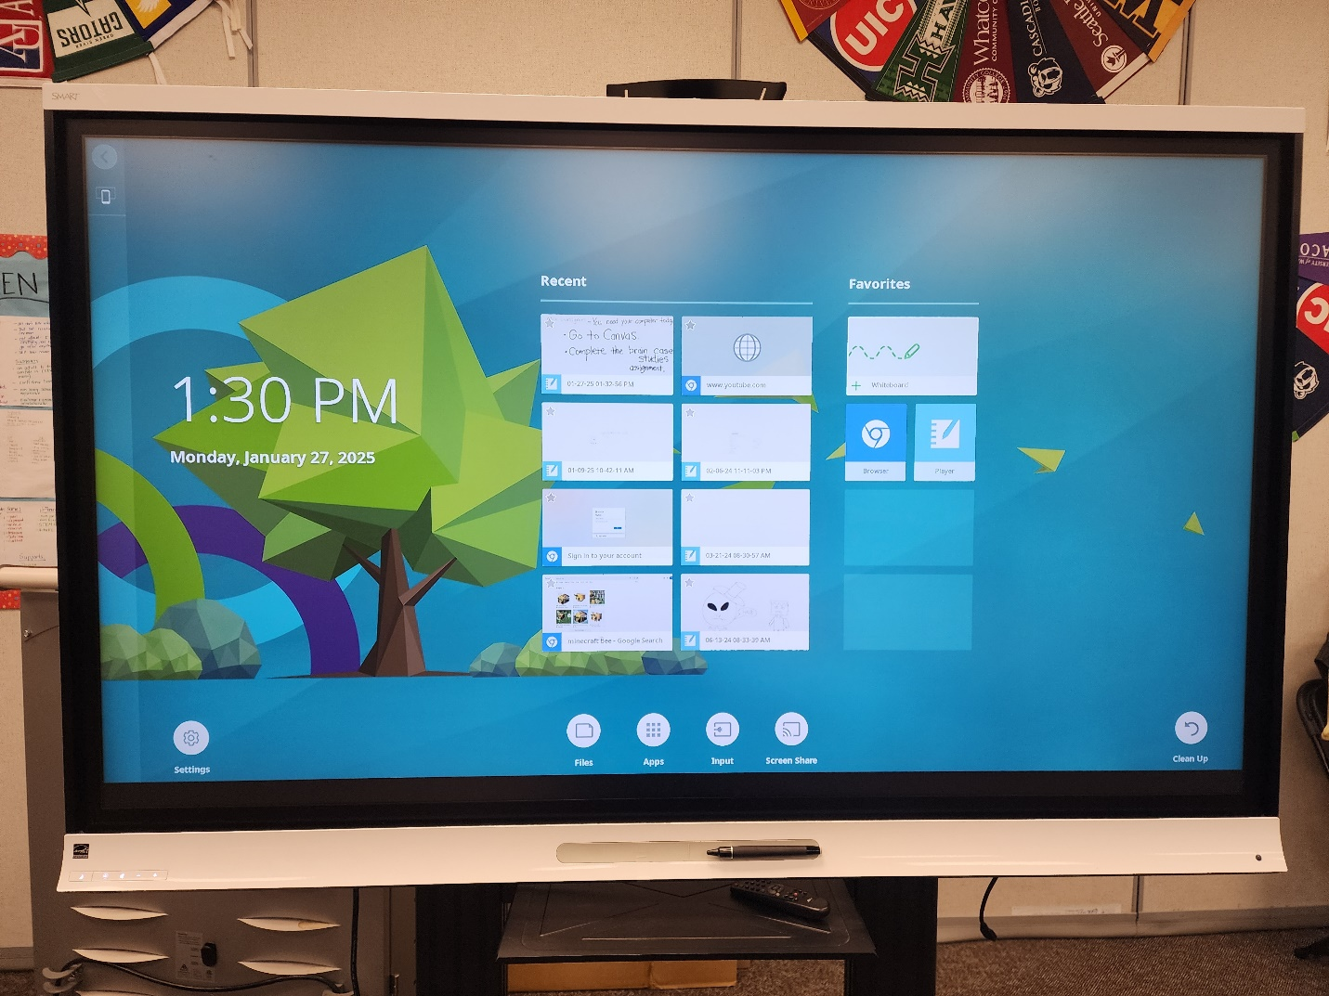
  - Click on the settings gear icon located on the bottom left
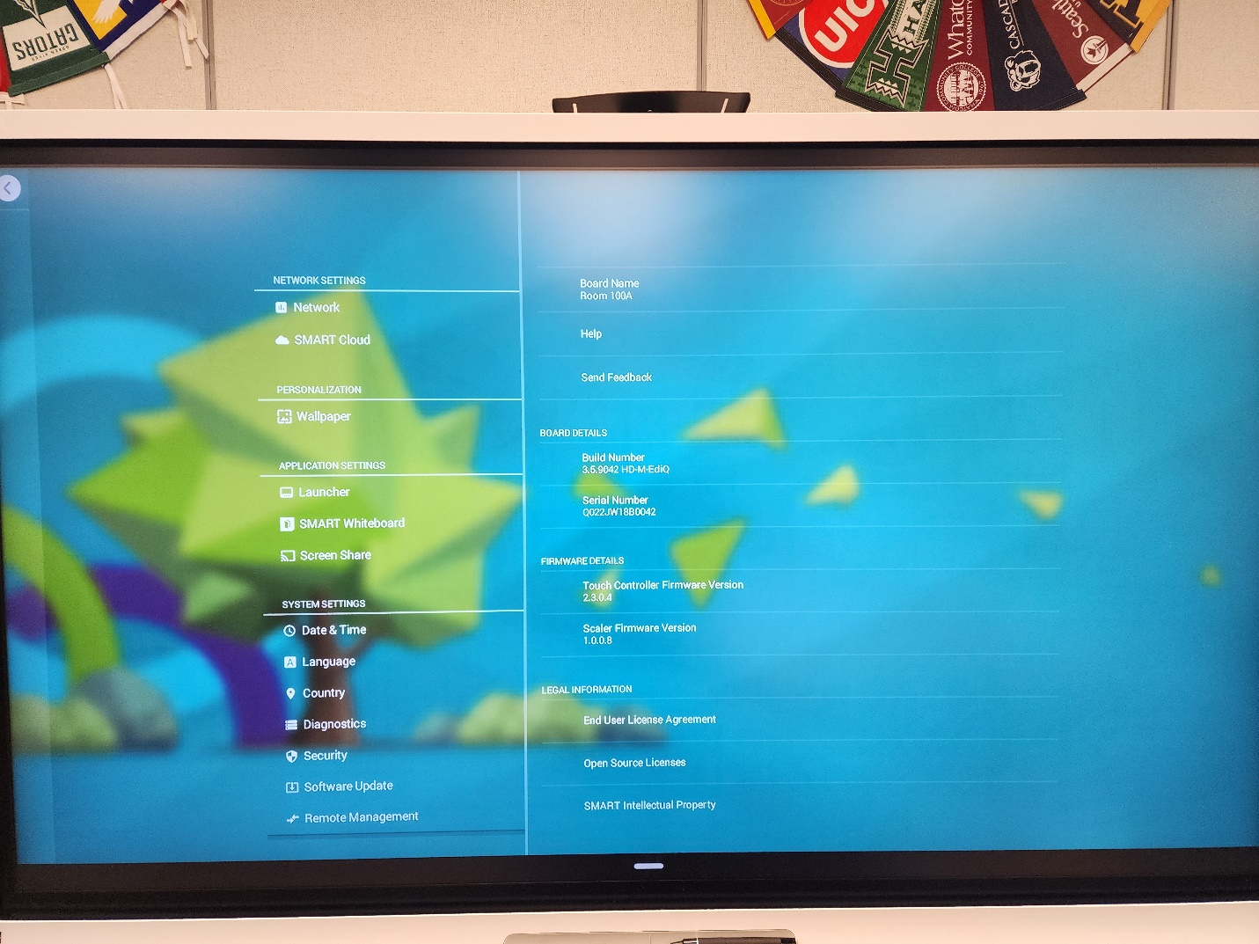
  - Select date and time
  - Uncheck the “automatic date and time” check box
  - After doing so, change the date and time by selecting either option and correcting the date and time manually.
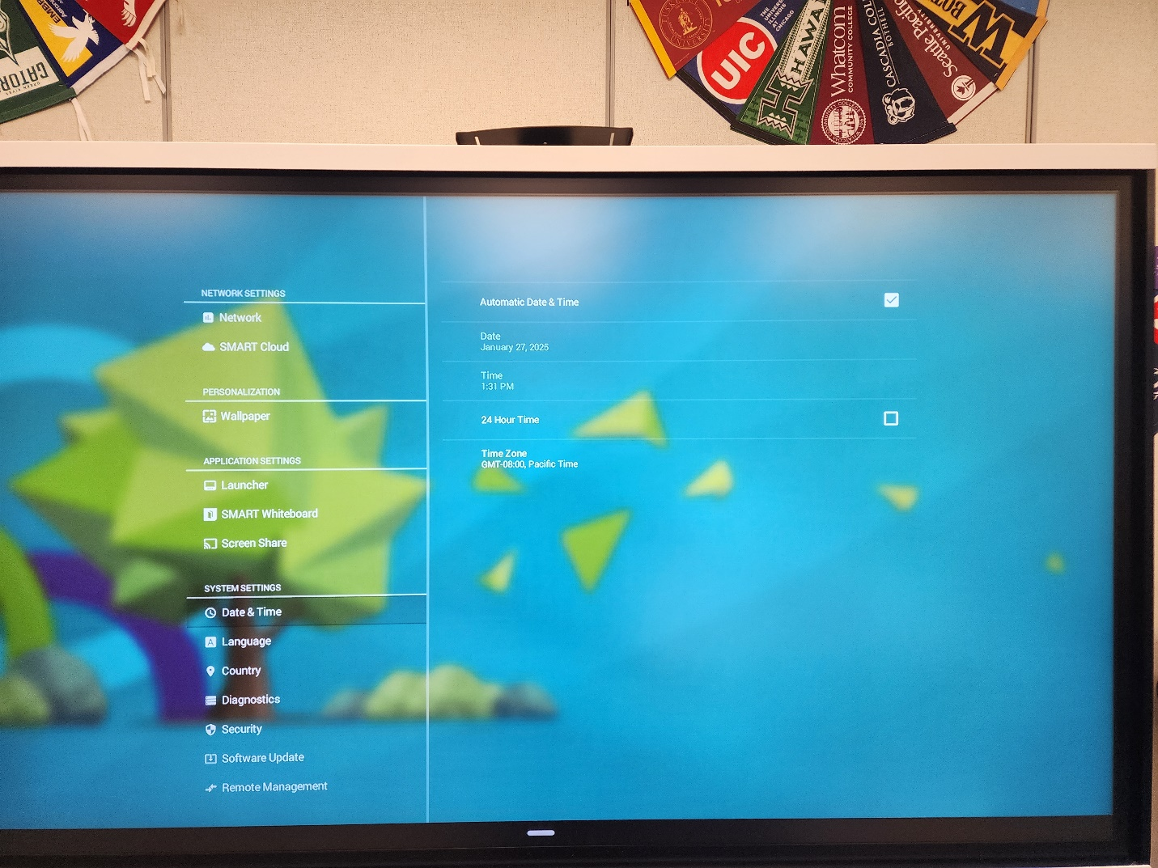

- How to restart the smartboard (crescent moon button)
  - When pressing the crescent moon button (pictured below) you’ll be able to restart the smartboard
  - Press and hold down the crescent moon button until the smartboard turns black and it has now been restarted

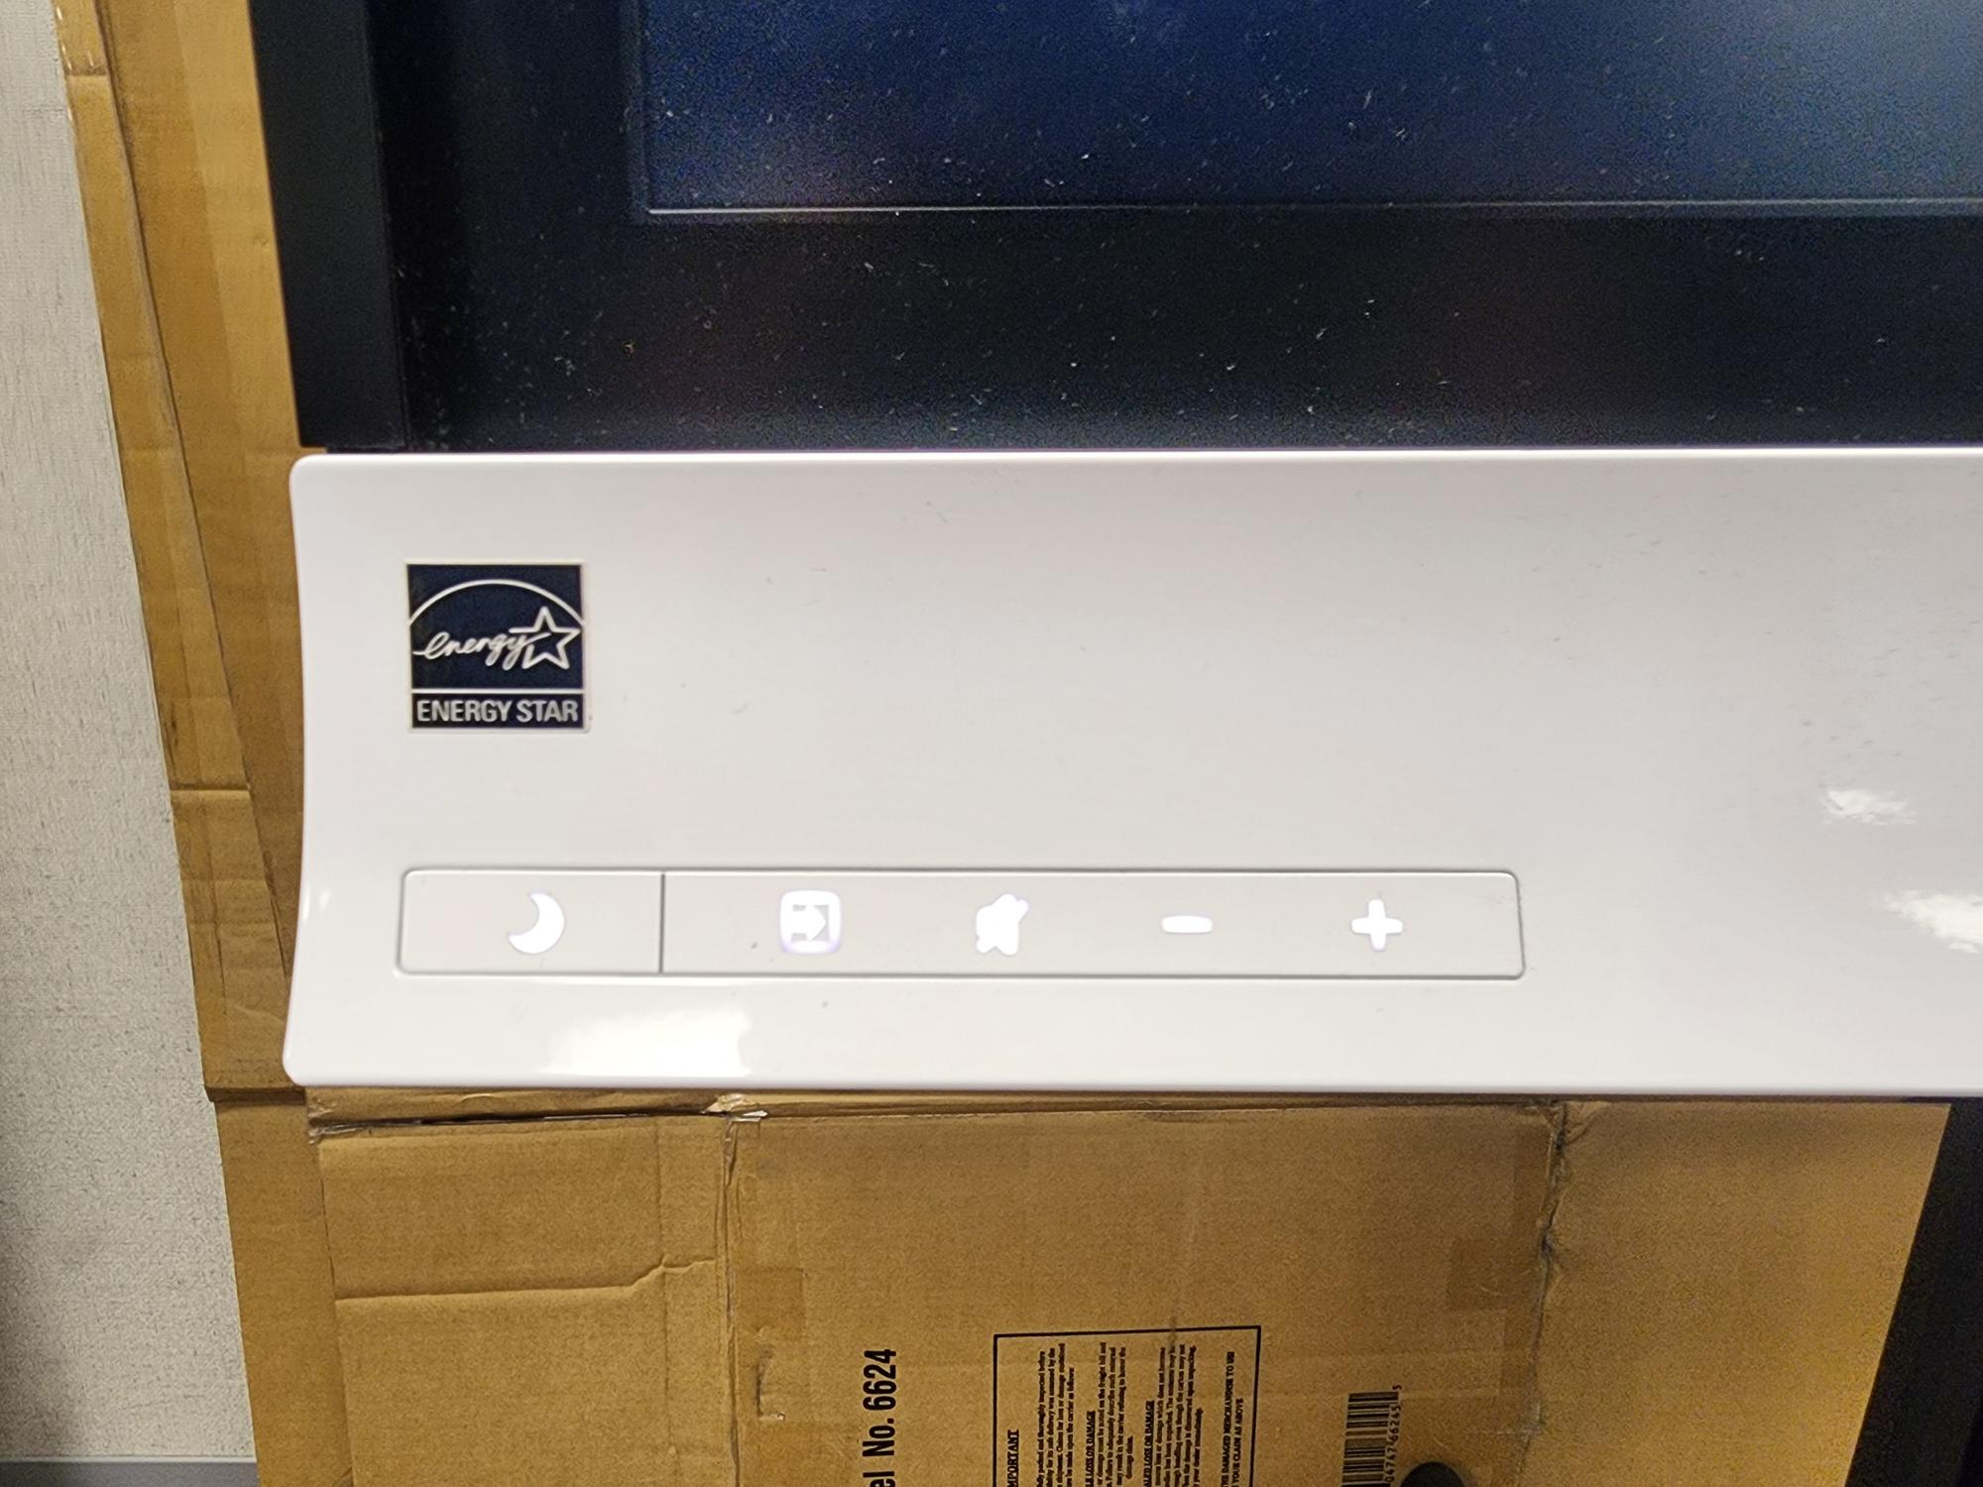
- How to change you video source
  - To change your video source you will press the button right next to the crescent moon button (blue arrow pointing to it)
  - Select your desired video source (hdmi 1, hdmi 2, ops hdmi are the main ones you’ll be using)
    - OPS Hdmi is the source you want if you want to use the smartboard by itself
    - The other HDMI inputs will be used if you want to use the laptop with the smartboard

- Where’s the home button?
  - The home button is located directly in the lower portion center of the screen
  - You will not be able to see this home button on the home screen
  - To access the home button you must be on another screen that isn’t the home screen
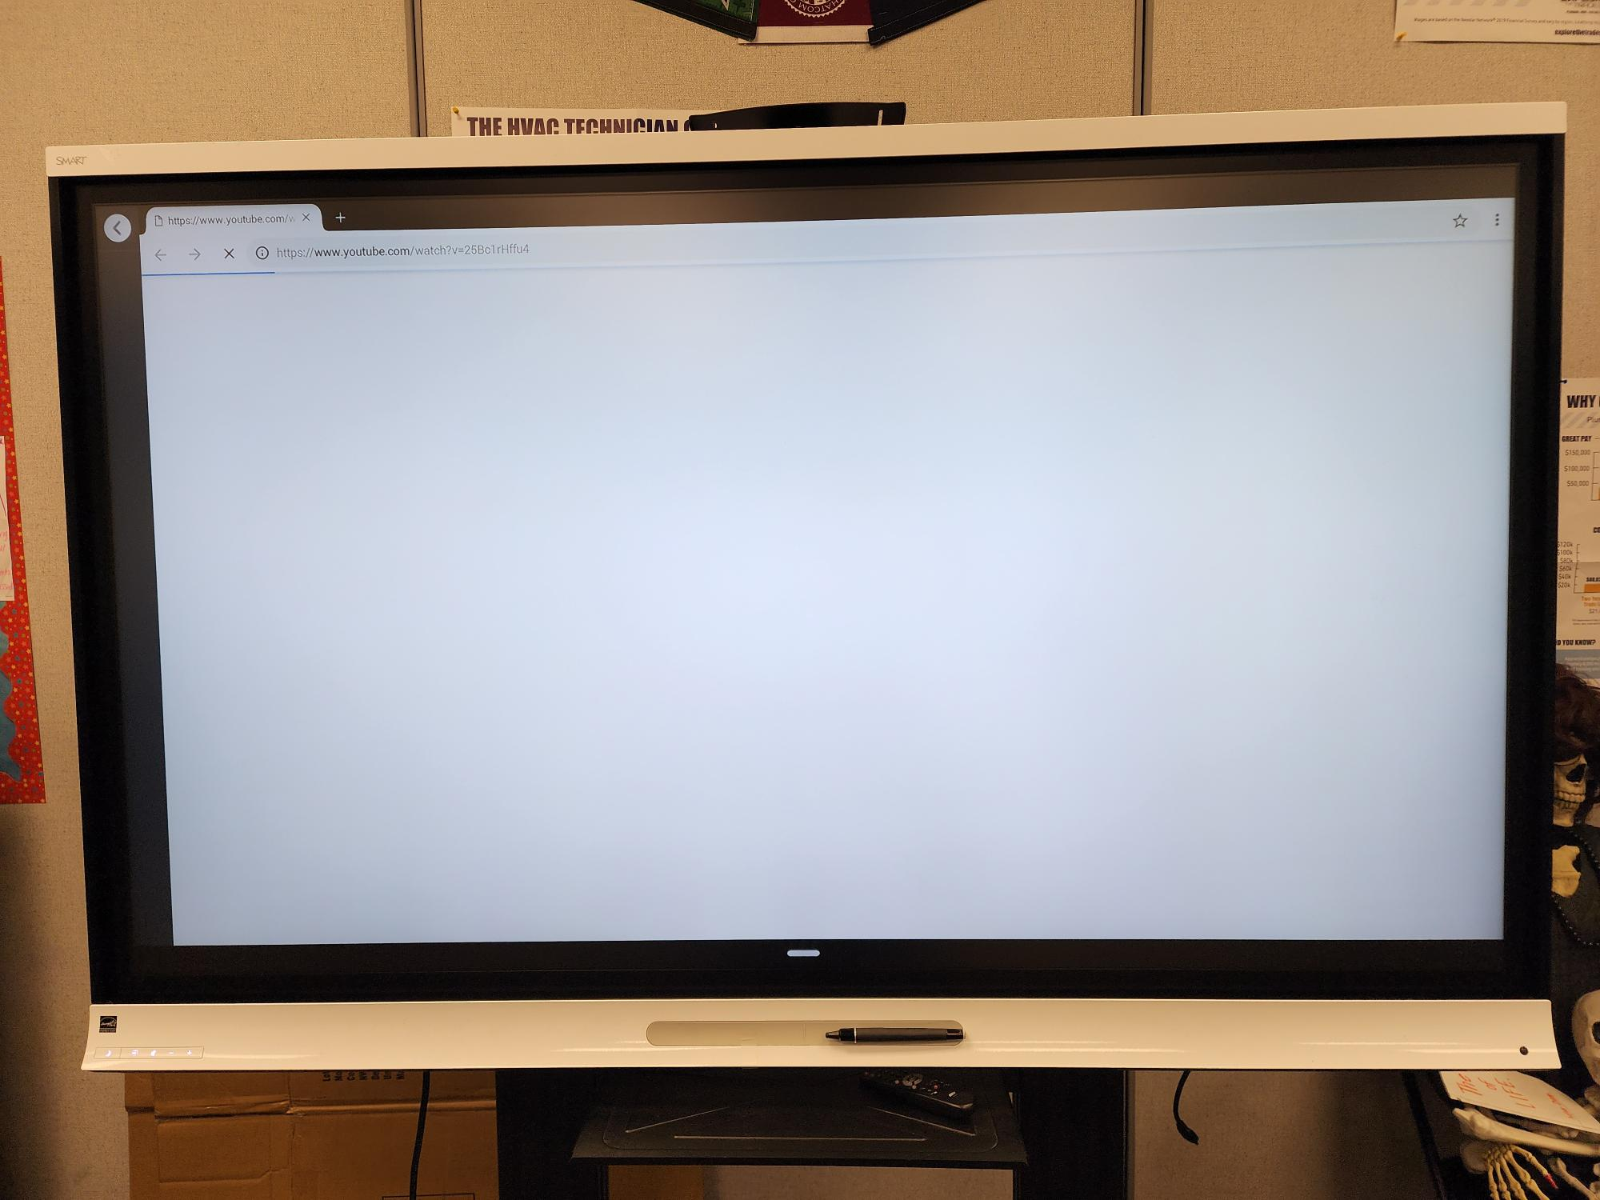

- Need to know how to access the web browser on the smartboard?
  - The browser icon may be located in a different place on the home screen, the main thing is to look for the browser icon
    - Things to remember: Smartboards are not equipped to play movies from streaming websites
